Full Code Report – BlazeDemo
Prepared By- Kashif Akhtar
Package Explorer:
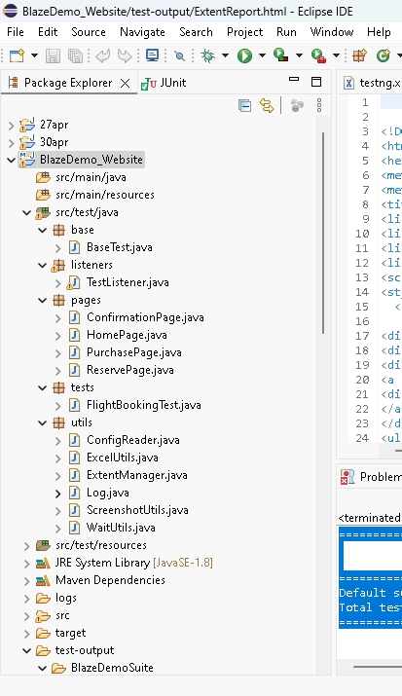

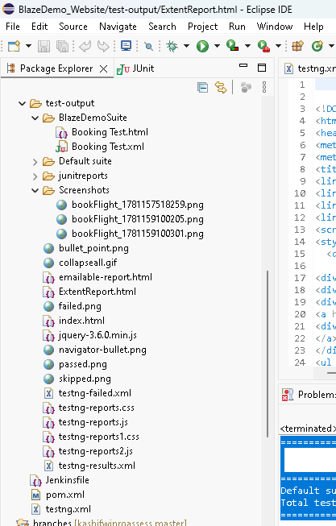
CODE:
Package: base-
package base;

import java.lang.reflect.Method;
import java.time.Duration;

import org.openqa.selenium.WebDriver;
import org.openqa.selenium.chrome.ChromeDriver;
import org.testng.ITestResult;
import org.testng.annotations.AfterMethod;
import org.testng.annotations.AfterSuite;
import org.testng.annotations.BeforeMethod;

import com.aventstack.extentreports.ExtentReports;
import com.aventstack.extentreports.ExtentTest;

import utils.ExtentManager;
import utils.ScreenshotUtils;

public class BaseTest {

public static WebDriver driver;

protected static ExtentReports extent =
ExtentManager.getReport();

protected ExtentTest test;

@BeforeMethod
public void setup(Method Method) {

driver = new ChromeDriver();

driver.manage().window().maximize();

driver.manage().timeouts()
.implicitlyWait(Duration.ofSeconds(10));

driver.get("https://blazedemo.com");

test = extent.createTest(Method.getName());

}
public static WebDriver getDriver() {
return driver;
}

@AfterMethod
public void tearDown(ITestResult result) {

try {

if (result.getStatus() == ITestResult.FAILURE) {

System.out.println("Failure block entered");

String screenshotPath =
ScreenshotUtils.captureScreenshot(
driver,
result.getName());

System.out.println(screenshotPath);
}
else if (result.getStatus() == ITestResult.SKIP) {

test.skip("Test Skipped");
}

} catch (Exception e) {

e.printStackTrace();
}

if (driver != null) {

driver.quit();
}
}

@AfterSuite
public void flushReport() {

extent.flush();
}
}
Package : pages-
Class-Confiramtion Page
package pages;

import org.openqa.selenium.*;

public class ConfirmationPage {

WebDriver driver;

public ConfirmationPage(WebDriver driver) {

this.driver = driver;
}

public String getConfirmationMessage() {

return driver.findElement(By.tagName("h1"))
.getText();
}
}

Class- HomePage
package pages;

import org.openqa.selenium.By;
import org.openqa.selenium.WebDriver;
import org.openqa.selenium.WebElement;

import org.openqa.selenium.support.ui.Select;

import utils.WaitUtils;

public class HomePage {

private WebDriver driver;
private WaitUtils wait;

public HomePage(WebDriver driver) {
this.driver = driver;
this.wait = new WaitUtils(driver);
}

private By departureDropdown = By.name("fromPort");
private By destinationDropdown = By.name("toPort");
private By findFlightsButton = By.cssSelector("input[type='submit']");

public String getPageTitle() {
return driver.getTitle();
}

public String getPageUrl() {
return driver.getCurrentUrl();
}

public boolean isDepartureDropdownDisplayed() {
WebElement element = driver.findElement(departureDropdown);
wait.waitForVisibility(element);
return element.isDisplayed();
}

public boolean isDestinationDropdownDisplayed() {
WebElement element = driver.findElement(destinationDropdown);
wait.waitForVisibility(element);
return element.isDisplayed();
}

public boolean isFindFlightsButtonDisplayed() {
WebElement element = driver.findElement(findFlightsButton);
wait.waitForVisibility(element);
return element.isDisplayed();
}

public void selectDepartureCity(String city) {
Select select = new Select(driver.findElement(departureDropdown));
select.selectByVisibleText(city);
}

public void selectDestinationCity(String city) {
Select select = new Select(driver.findElement(destinationDropdown));
select.selectByVisibleText(city);
}

public void clickFindFlights() {
WebElement button = driver.findElement(findFlightsButton);
wait.waitForClickable(button);
button.click();
}
}
Class – PurchasePage
package pages;

import org.openqa.selenium.*;
import org.openqa.selenium.support.ui.Select;

public class PurchasePage {

WebDriver driver;

public PurchasePage(WebDriver driver) {

this.driver = driver;
}

public void enterPassengerDetails(

String name,
String address,
String city,
String state,
String zip,
String cardType,
String cardNumber,
String month,
String year,
String nameOnCard) {

driver.findElement(By.name("inputName"))
.sendKeys(name);

driver.findElement(By.name("address"))
.sendKeys(address);

driver.findElement(By.name("city"))
.sendKeys(city);

driver.findElement(By.name("state"))
.sendKeys(state);

driver.findElement(By.name("zipCode"))
.sendKeys(zip);

Select card =
new Select(driver.findElement(By.name("cardType")));

card.selectByVisibleText(cardType);

driver.findElement(By.name("creditCardNumber"))
.sendKeys(cardNumber);

driver.findElement(By.name("creditCardMonth"))
.clear();

driver.findElement(By.name("creditCardMonth"))
.sendKeys(month);

driver.findElement(By.name("creditCardYear"))
.clear();

driver.findElement(By.name("creditCardYear"))
.sendKeys(year);

driver.findElement(By.name("nameOnCard"))
.sendKeys(nameOnCard);

WebElement remember =
driver.findElement(By.name("rememberMe"));

if(!remember.isSelected()) {
remember.click();
}
}

public void clickPurchaseFlight() {

driver.findElement(
By.cssSelector("input[type='submit']"))
.click();
}
}
Class-ReservePage
package pages;

import java.util.List;

import org.openqa.selenium.*;

public class ReservePage {

WebDriver driver;

public ReservePage(WebDriver driver) {
this.driver = driver;
}

public boolean verifyFlightsDisplayed() {

List<WebElement> rows =
driver.findElements(
By.xpath("//table/tbody/tr"));

return rows.size()>0;
}

public void chooseFlight() {

driver.findElement(
By.xpath("(//input[@value='Choose This Flight'])[1]"))
.click();
}
}
Package: listeners
package listeners;

import org.openqa.selenium.WebDriver;
import org.testng.ITestListener;
import org.testng.ITestResult;

import base.BaseTest;
import utils.ScreenshotUtils;

public class TestListener implements ITestListener {

@Override
public void onTestStart(ITestResult result) {
System.out.println("STARTED : " + result.getName());
}

@Override
public void onTestSuccess(ITestResult result) {
System.out.println("PASSED : " + result.getName());
}

@Override
public void onTestFailure(ITestResult result) {

System.out.println("FAILED : " + result.getName());

System.out.println("onTestSuccessTriggered");

ScreenshotUtils.captureScreenshot(
BaseTest.getDriver(),
result.getName());
}

@Override
public void onTestSkipped(ITestResult result) {
System.out.println("SKIPPED : " + result.getName());
}
}
Package : Utils
Class-ExcelUtils.java
package utils;

import java.io.FileInputStream;

import org.apache.poi.ss.usermodel.*;

public class ExcelUtils {

public static Object[][] getExcelData() {

Object[][] data = null;

try {

FileInputStream fis =
new FileInputStream(
"src/test/resources/testdata/BookingData.xlsx");

Workbook wb =
WorkbookFactory.create(fis);

Sheet sheet =
wb.getSheetAt(0);

int rows =
sheet.getPhysicalNumberOfRows();

int cols =
sheet.getRow(0).getLastCellNum();

data =
new Object[rows-1][cols];

for(int i=1;i<rows;i++) {

for(int j=0;j<cols;j++) {

data[i-1][j] =
sheet.getRow(i)
.getCell(j)
.toString();
}
}

wb.close();

} catch(Exception e) {

e.printStackTrace();
}

return data;
}
}
Class-ExtentManager.java
package utils;

import com.aventstack.extentreports.ExtentReports;
import com.aventstack.extentreports.reporter.ExtentSparkReporter;

public class ExtentManager {

private static ExtentReports extent;

public static ExtentReports getReport() {

if (extent == null) {

ExtentSparkReporter spark =
new ExtentSparkReporter(
"test-output/ExtentReport.html");

spark.config().setDocumentTitle(
"BlazeDemo Report");

spark.config().setReportName(
"Automation Execution Report");

extent = new ExtentReports();

extent.attachReporter(spark);

extent.setSystemInfo(
"Tester",
"Kashif Akhtar");

extent.setSystemInfo(
"Environment",
"QA");
}

return extent;
}
}
Class- ConfigReader.java
package utils;

import java.io.FileInputStream;
import java.util.Properties;

public class ConfigReader {

private static Properties properties;

static {
try {
properties = new Properties();
FileInputStream fis = new FileInputStream("src/test/resources/config/config.properties");
properties.load(fis);
} catch (Exception e) {
throw new RuntimeException("Unable to load config file", e);
}
}

public static String getProperty(String key) {
return properties.getProperty(key);
}
}
ScreenshotUtils:Class
package utils;

import java.io.File;
import java.io.IOException;

import org.openqa.selenium.OutputType;
import org.openqa.selenium.TakesScreenshot;
import org.openqa.selenium.WebDriver;
import org.openqa.selenium.io.FileHandler;

public class ScreenshotUtils {

public static String captureScreenshot(WebDriver driver,
String testName) {
System.out.println("E:\\BlazeDemo_Website"+System.getProperty("user.dir"));
System.out.println("Screenshot method called");

if(driver == null) {
System.out.println("Driver is null");
return null;
}

String path = System.getProperty("user.dir")
+ File.separator
+ "test-output"
+ File.separator
+ "Screenshots";

File folder = new File(path);

if(!folder.exists()) {
folder.mkdirs();
}

String screenshotPath =
path + File.separator
+ testName + "_"
+ System.currentTimeMillis()
+ ".png";

try {

File source =
((TakesScreenshot)driver)
.getScreenshotAs(OutputType.FILE);

File destination =
new File(screenshotPath);

FileHandler.copy(source, destination);

System.out.println(
"Screenshot saved successfully: "
+ screenshotPath);

}
catch(IOException e) {

e.printStackTrace();
}

return screenshotPath;
}
}
Class- Log.java
package utils;

import org.apache.logging.log4j.LogManager;
import org.apache.logging.log4j.Logger;

public class Log {

private static final Logger logger = LogManager.getLogger(Log.class);
private Log() {}
public static void info(String message) {
logger.info(message);
}
}
Class-WaitUtils.java
package utils;

import java.time.Duration;

import org.openqa.selenium.WebDriver;
import org.openqa.selenium.WebElement;
import org.openqa.selenium.support.ui.ExpectedConditions;
import org.openqa.selenium.support.ui.WebDriverWait;

public class WaitUtils {

private WebDriverWait wait;

public WaitUtils(WebDriver driver) {
try {
wait = new WebDriverWait(driver,Duration.ofSeconds(20));
} catch (Exception e) {
throw new RuntimeException("Unable to initialize WaitUtils", e);
}
}

public void waitForVisibility(WebElement element) {
try {
wait.until(ExpectedConditions.visibilityOf(element));
} catch (Exception e) {
throw new RuntimeException("Element not visible", e);
}
}

public void waitForClickable(WebElement element) {

try {
wait.until(ExpectedConditions.elementToBeClickable(element));
} catch (Exception e) {
throw new RuntimeException("Element not clickable", e);
}
}

public void waitForTitle(String title) {

try {
wait.until(ExpectedConditions.titleContains(title));
} catch (Exception e) {
throw new RuntimeException("Title not found : " + title, e);
}
}

public void waitForUrl(String url) {

try {
wait.until(ExpectedConditions.urlContains(url));
} catch (Exception e) {
throw new RuntimeException("URL not found : " + url, e);
}
}
}
Package:tests
Class-FlightBookingTest.java
package tests;

import org.testng.Assert;
import org.testng.annotations.DataProvider;
import org.testng.annotations.Test;

import base.BaseTest;
import pages.*;
import utils.ExcelUtils;

import org.testng.annotations.Listeners;

@Listeners(listeners.TestListener.class)
public class FlightBookingTest extends BaseTest {

@DataProvider(name="bookingData")
public Object[][] getData() {

return ExcelUtils.getExcelData();
}

@Test(dataProvider="bookingData")
public void bookFlight(

String fromPort,
String toPort,
String name,
String address,
String city,
String state,
String zipCode,
String cardType,
String cardNumber,
String month,
String year,
String nameOnCard) {

HomePage home =
new HomePage(driver);

home.selectDepartureCity(fromPort);
home.selectDestinationCity(toPort);
home.clickFindFlights();

ReservePage reserve =
new ReservePage(driver);

Assert.assertTrue(
reserve.verifyFlightsDisplayed());

reserve.chooseFlight();

PurchasePage purchase =
new PurchasePage(driver);

purchase.enterPassengerDetails(
name,
address,
city,
state,
zipCode,
cardType,
cardNumber,
month,
year,
nameOnCard);

purchase.clickPurchaseFlight();

ConfirmationPage confirm =
new ConfirmationPage(driver);

Assert.assertEquals(
confirm.getConfirmationMessage(),
"Thank you for your purchase today!");

}
}
Src/test/resources
Folder-Config.Reader
url=https://blazedemo.com
browser=chrome

Folder-BookinData.xlsx
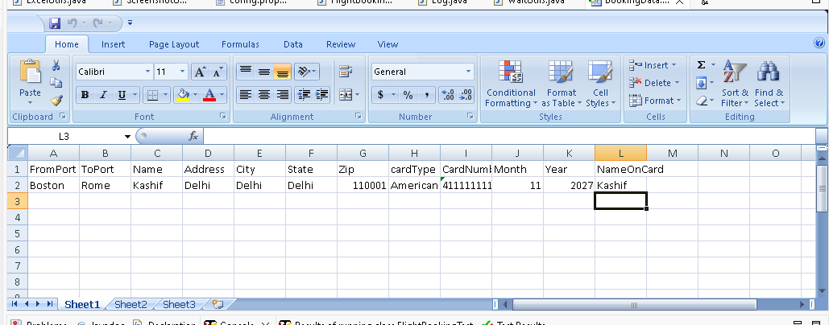
ExtentReport.html
<!DOCTYPE html>
<html>
<head>
<meta charset="UTF-8">
<meta name="viewport" content="width=device-width, initial-scale=1, shrink-to-fit=no">
<title>BlazeDemo Report</title>
<link rel="apple-touch-icon" href="https://cdn.jsdelivr.net/gh/extent-framework/extent-github-cdn@b00a2d0486596e73dd7326beacf352c639623a0e/commons/img/logo.png">
<link rel="shortcut icon" href="https://cdn.jsdelivr.net/gh/extent-framework/extent-github-cdn@b00a2d0486596e73dd7326beacf352c639623a0e/commons/img/logo.png">
<link href="https://cdn.jsdelivr.net/gh/extent-framework/extent-github-cdn@ce8b10435bcbae260c334c0d0c6b61d2c19b6168/spark/css/spark-style.css" rel="stylesheet" />
<link href="https://stackpath.bootstrapcdn.com/font-awesome/4.7.0/css/font-awesome.min.css" rel="stylesheet">
<script src="https://cdn.jsdelivr.net/gh/extent-framework/extent-github-cdn@7cc78ce/spark/js/jsontree.js"></script>
<style type="text/css"></style></head><body class="spa -report standard">
<div class="app">
<div class="layout">
<div class="header navbar">
<div class="vheader">
<div class="nav-logo">
<a href="#">
<div class="logo" style="background-image: url('https://cdn.jsdelivr.net/gh/extent-framework/extent-github-cdn@b00a2d0486596e73dd7326beacf352c639623a0e/commons/img/logo.png')"></div>
</a>
</div>
<ul class="nav-left">
<li class="search-box">
<a class="search-toggle" href="#">
<i class="search-icon fa fa-search"></i>
<i class="search-icon-close fa fa-close"></i>
</a>
</li>
<li class="search-input"><input id="search-tests" class="form-control" type="text" placeholder="Search..."></li>
</ul>
<ul class="nav-right">
<li class="m-r-10">
<a href="#"><span class="badge badge-primary">Automation Execution Report</span></a>
</li>
<li class="m-r-10">
<a href="#"><span class="badge badge-primary">Jun 11, 2026 11:56:13 AM</span></a>
</li>
</ul>
</div>
</div><div class="side-nav">
<div class="side-nav-inner">
<ul class="side-nav-menu">
<li class="nav-item dropdown" onclick="toggleView('test-view')">
<a id="nav-test" class="dropdown-toggle" href="#">
<span class="ico"><i class="fa fa-list"></i></span>
</a>
</li>
<li class="nav-item dropdown" onclick="toggleView('dashboard-view')">
<a id="nav-dashboard" class="dropdown-toggle" href="#">
<span class="ico"><i class="fa fa-bar-chart"></i></span>
</a>
</li>
</ul>
</div>
</div> <div class="vcontainer">
<div class="main-content">
<div class="test-wrapper row view test-view">
<div class="test-list">
<div class="test-list-tools">
<ul class="tools pull-left">
<li><a href="#"><span class="font-size-14">Tests</span></a></li>
</ul>
<ul class="tools text-right">
<li class="dropdown">
<a href="#" class="dropdown-toggle" data-toggle="dropdown"><i class="fa fa-exclamation-circle"></i></a>
<ul id="status-toggle" class="dropdown-menu dropdown-md p-v-0">
<a class="dropdown-item" status="pass" href="#"><span>Pass</span><span class="status success"></span></a>
<div class="dropdown-divider"></div>
<a status="clear" class="dropdown-item" href="#"><span>Clear</span><span class="pull-right"><i class="fa fa-close"></i></span></a>
</ul>
</li>
</ul>
</div> <div class="test-list-wrapper scrollable">
<ul class="test-list-item">
<li class="test-item" status="pass" test-id="1"
author=""
tag=""
device="">
<div class="test-detail">
<p class="name">bookFlight</p>
<p class="text-sm">
<span>11:56:20 AM</span> / <span>00:00:00:000</span>
<span class="badge pass-bg log float-right">Pass</span>
</p>
</div>
<div class="test-contents d-none">
<div class="detail-head">
<div class="p-v-10">
<div class="info">
<h5 class="test-status text-pass">bookFlight</h5>
<span class='badge badge-success'>06.11.2026 11:56:20 AM</span>
<span class='badge badge-danger'>06.11.2026 11:56:20 AM</span>
<span class='badge badge-default'>00:00:00:000</span>
&middot; <span class='uri-anchor badge badge-default'>#test-id=1</span>
<span title='Skip to the next failed step' class='badge badge-danger pointer float-right ne ml-1'><i class="fa fa-fast-forward"></i></span>
<span title='Collapse all nodes' class='badge badge-default pointer float-right ct ml-1'><i class="fa fa-compress"></i></span>
<span title='Expand all nodes' class='badge badge-default pointer float-right et'><i class="fa fa-expand"></i></span>
</div>
</div>
</div> </div>
</li>
</ul>
</div>
</div>
<div class="test-content scrollable">
<div class="test-content-tools">
<ul><li><a class="back-to-test" href="#"><i class="fa fa-arrow-left"></i></a></li></ul>
</div>
<div class="test-content-detail"><div class="detail-body"></div></div>
</div></div>
<div class="container-fluid p-4 view dashboard-view">
<div class="row">
<div class="col-md-3">
<div class="card"><div class="card-body">
<p class="m-b-0">Started</p>
<h3>Jun 11, 2026 11:56:13 AM</h3>
</div></div>
</div>
<div class="col-md-3">
<div class="card"><div class="card-body">
<p class="m-b-0">Ended</p>
<h3>Jun 11, 2026 11:56:25 AM</h3>
</div></div>
</div>
<div class="col-md-3">
<div class="card"><div class="card-body">
<p class="m-b-0 text-pass">Tests Passed</p>
<h3>1</h3>
</div></div>
</div>
<div class="col-md-3">
<div class="card"><div class="card-body">
<p class="m-b-0 text-fail">Tests Failed</p>
<h3>0</h3>
</div></div>
</div>
</div>
<div class="row">
<div class="col-md-6">
<div class="card">
<div class="card-header">
<h6 class="card-title">Tests</h6>
</div>
<div class="card-body">
<div class="">
<canvas id='parent-analysis' width='115' height='90'></canvas>
</div>
</div>
<div class="card-footer">
<div><small data-tooltip='100%'>
<b>1</b> tests passed
</small>
</div>
<div>
<small data-tooltip='0%'><b>0</b> tests failed,
<b>0</b> skipped, <b data-tooltip='0%'>0</b> others
</small>
</div>
</div>
</div>
</div>
</div>
<div class="row"><div class="col-md-12">
<div class="card"><div class="card-header"><p>Timeline</p></div>
<div class="card-body pt-0"><div>
<canvas id="timeline" height="120"></canvas>
</div></div>
</div>
</div></div>
<script>
var timeline = {
"bookFlight":0
};
</script>
<div class="row">
<div class="col-lg-6 col-md-12 sysenv-container">
<div class="card">
<div class="card-header"><p>System/Environment</p></div>
<div class="card-body pb-0 pt-0"><table class="table table-sm table-bordered">
<thead><tr class="bg-gray"><th>Name</th><th>Value</th></tr></thead>
<tbody>
<tr>
<td>Tester</td>
<td>Kashif Akhtar</td>
</tr>
<tr>
<td>Environment</td>
<td>QA</td>
</tr>
</tbody>
</table></div>
</div>
</div>
</div>
</div>
<script>
var statusGroup = {
parentCount: 5,
passParent: 1,
failParent: 0,
warningParent: 0,
skipParent: 0,
childCount: 5,
passChild: 0,
failChild: 0,
warningChild: 0,
skipChild: 0,
infoChild: 0,
grandChildCount: 5,
passGrandChild: 0,
failGrandChild: 0,
warningGrandChild: 0,
skipGrandChild: 0,
infoGrandChild: 0,
eventsCount: 5,
passEvents: 0,
failEvents: 0,
warningEvents: 0,
skipEvents: 0,
infoEvents: 0
};
</script> </div>
</div>
</div>
</div>
<script src="https://cdn.jsdelivr.net/gh/extent-framework/extent-github-cdn@c05cd28cde1617b9d0c05a831daff6cb97fd9fd5/spark/js/spark-script.js"></script>
<script type="text/javascript"></script></body>
</html>

JenkinsFile:
pipeline {
agent any

tools {
maven 'Maven3'
}

stages {
stage('Compile') {
steps {
bat 'mvn compile'
}
}

stage('Test Execution') {
steps {
bat 'mvn test'
}
}
}

post {
always {
junit '**/target/surefire-reports/*.xml'
archiveArtifacts artifacts: '**/test-output/**/*', allowEmptyArchive: true
}
}
}

Pom.xml:
<project xmlns="http://maven.apache.org/POM/4.0.0" xmlns:xsi="http://www.w3.org/2001/XMLSchema-instance" xsi:schemaLocation="http://maven.apache.org/POM/4.0.0 https://maven.apache.org/xsd/maven-4.0.0.xsd">
<modelVersion>4.0.0</modelVersion>
<groupId>BlazeDemo</groupId>
<artifactId>BlazeDemo</artifactId>
<version>0.0.1-SNAPSHOT</version>
<dependencies>
<!-- Source: https://mvnrepository.com/artifact/org.seleniumhq.selenium/selenium-java -->
<dependency>
<groupId>org.seleniumhq.selenium</groupId>
<artifactId>selenium-java</artifactId>
<version>4.44.0</version>
<scope>compile</scope>
</dependency>

<!-- Source: https://mvnrepository.com/artifact/org.testng/testng -->
<dependency>
<groupId>org.testng</groupId>
<artifactId>testng</artifactId>
<version>7.12.0</version>
<scope>test</scope>
</dependency>

<!-- Source: https://mvnrepository.com/artifact/org.apache.poi/poi-ooxml -->
<dependency>
<groupId>org.apache.poi</groupId>
<artifactId>poi-ooxml</artifactId>
<version>5.5.1</version>
<scope>compile</scope>
</dependency>

<!-- Source: https://mvnrepository.com/artifact/commons-io/commons-io -->
<dependency>
<groupId>commons-io</groupId>
<artifactId>commons-io</artifactId>
<version>2.22.0</version>
<scope>compile</scope>
</dependency>

<!-- Source: https://mvnrepository.com/artifact/com.aventstack/extentreports -->
<dependency>
<groupId>com.aventstack</groupId>
<artifactId>extentreports</artifactId>
<version>5.1.2</version>
<scope>compile</scope>
</dependency>

<!-- Source: https://mvnrepository.com/artifact/org.apache.logging.log4j/log4j-api -->
<dependency>
<groupId>org.apache.logging.log4j</groupId>
<artifactId>log4j-api</artifactId>
<version>2.26.0</version>
<scope>compile</scope>
</dependency>

<!-- Source: https://mvnrepository.com/artifact/org.apache.logging.log4j/log4j-core -->
<dependency>
<groupId>org.apache.logging.log4j</groupId>
<artifactId>log4j-core</artifactId>
<version>2.26.0</version>
<scope>compile</scope>
</dependency>
</dependencies>
</project>
Testng.xml:
<!DOCTYPE suite SYSTEM
"https://testng.org/testng-1.0.dtd">

<suite name="BlazeDemoSuite">
<listeners>
<listener class-name = "listeners.TestListener"/>
</listeners>

<test name="Booking Test">

<classes>

<class name="tests.FlightBookingTest"/>

</classes>

</test>

</suite>

CodeExecution Screenshot:
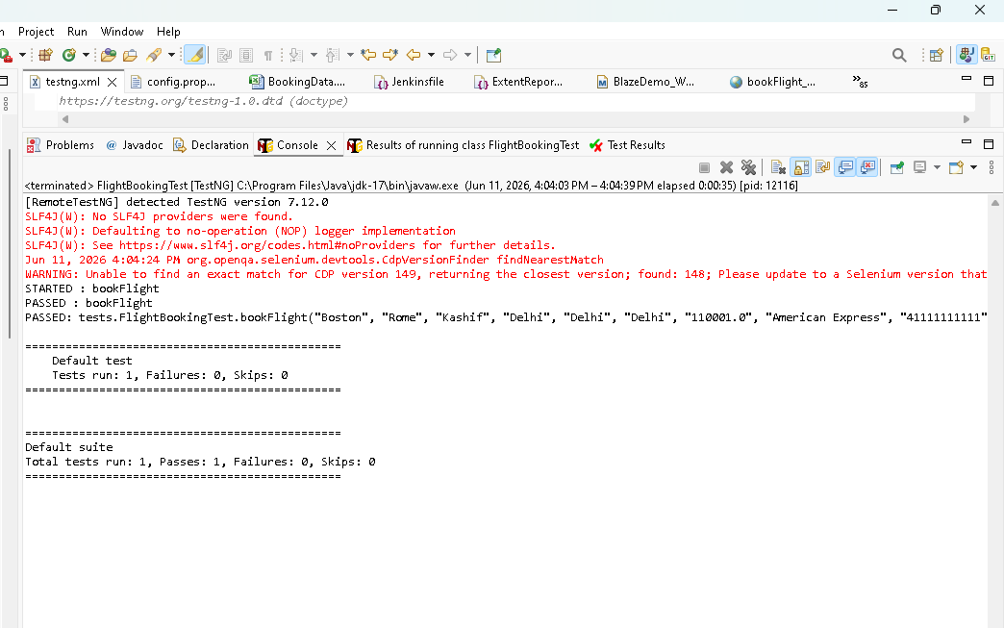

TestNG Report SS:
